**Naveen Bonala Vpc & Nat gateway & Vpc peering**

1. Create one VPC, with 1 one public subnet and 1 private subnet

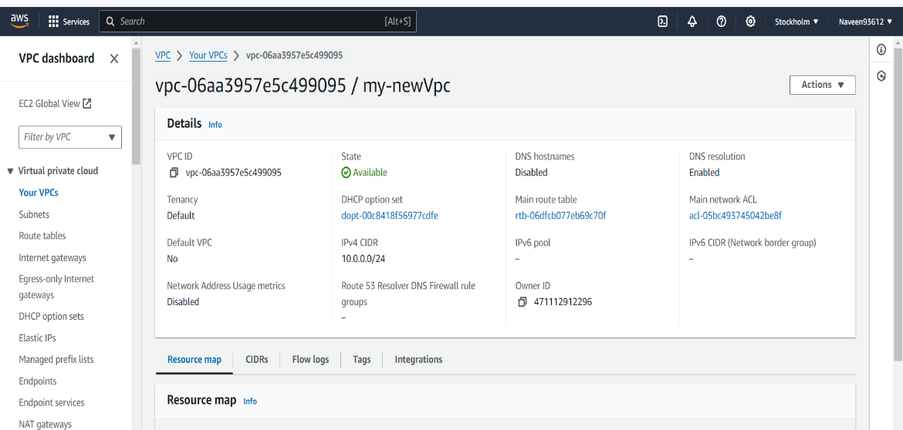

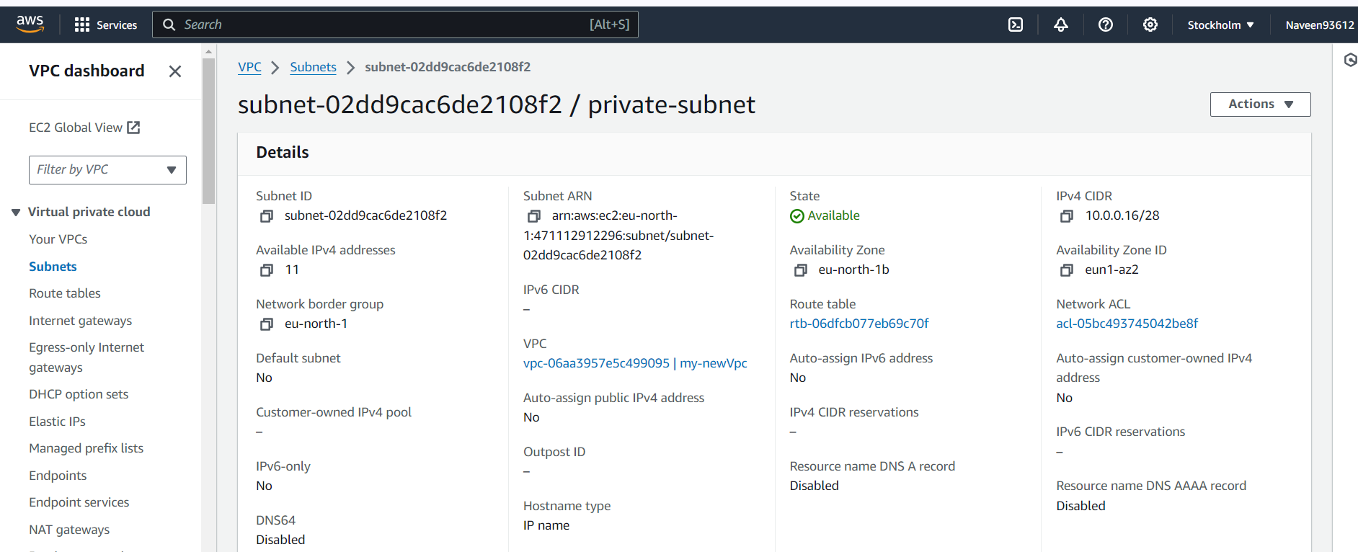

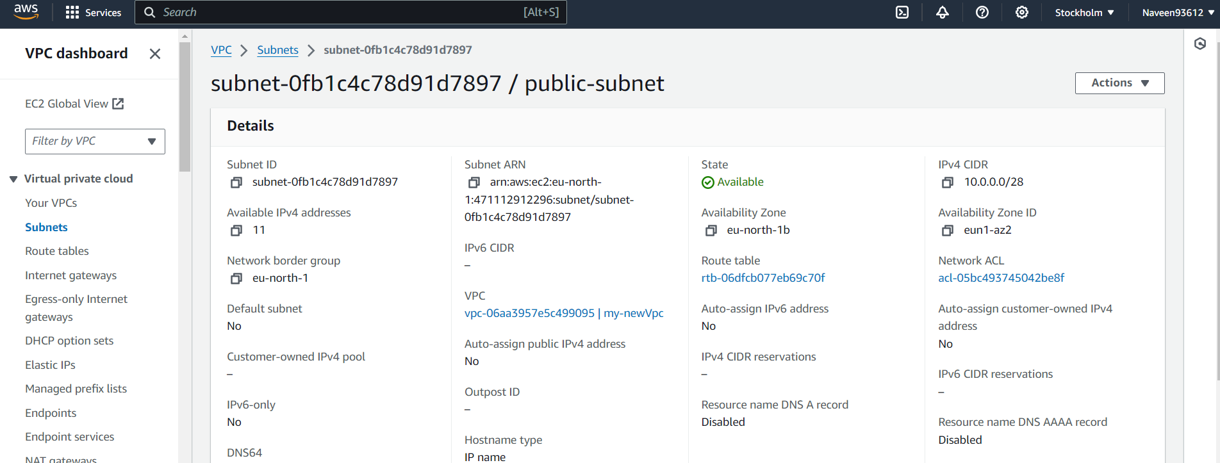

1. Enable VPC peering for cross region.

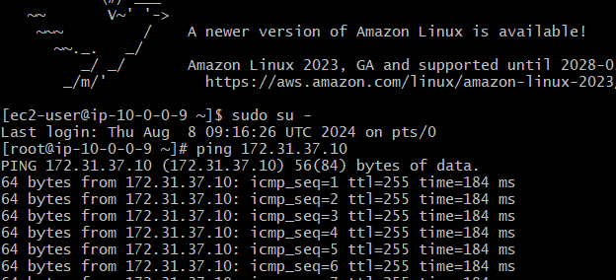

1. Enable VPC peering for cross account. (You can collaborate with your friend and do this task).

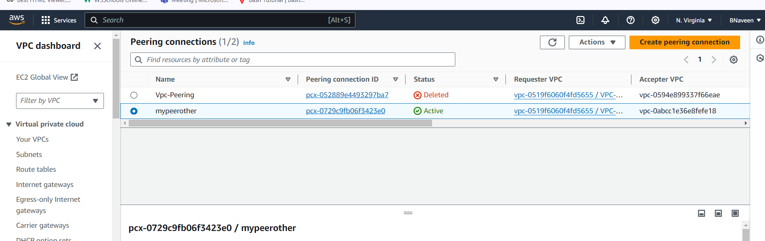

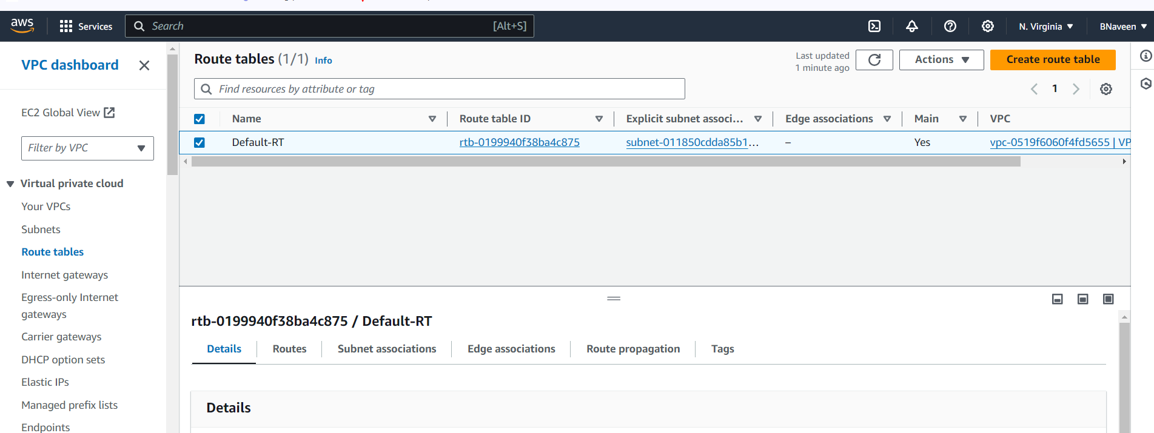

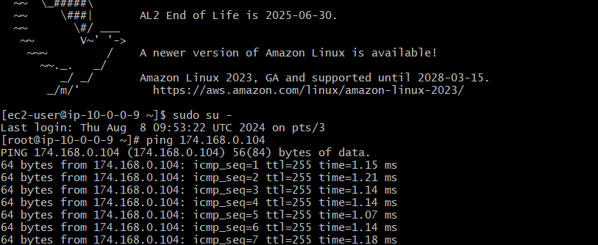

1. Bash script to setup one vpc,1 public and 1 private subnet with IGW, RT and need to launch one ec2 in public and one ec2 in private in `SEOUL REGION` ONLY.

